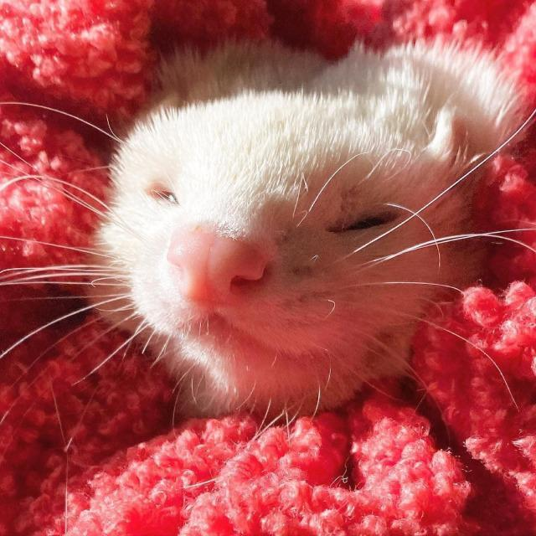
Mustelo furo, or the ferret, is a small, sexually dimorphic animal species belonging to the family Mustelidae. Ferrets exhibit interfertility with other mustelids, especially the European polecat. Consequently, they are widely thought to be the domesticated form of the polecats. Moreover, similarly to other mustelids (skunk, mink, badger), the ferret is a seasonally polyestrous breeder. Exposure to light and nutrition are major factors influencing the success and the timing of reproduction.
Sexual Determination and Maturity
The sex of a newborn ferret can be easily determined by the length of the anogenital space. Male ferrets have a palpable os penis and the urogenital opening is located ventrally on the abdomen. Female ferrets, on the other hand, have a narrow anogenital space. Ferrets usually reach sexual maturity around 8 to 12 months of age, with males weighing around two times more than females.
Sexual Discrimination
The ability of ferrets to distinguish the sex of other ferrets relies heavily on chemosignals resulting from glandular and urinal secretions. Some of the major elements that are unique to anal gland secretions—thietanes, dithiolanes, indole—have been shown to play a major role in the discrimination between the two sexes; female ferrets were observed to be attracted to the anal secretions of male ferrets and vice versa. Moreover, behavioral studies conducted on European polecats show that the females prefer the urine of the opposite sex, and the males prefer that of the females as well, suggesting urine relays information relating to sex as well. Seeing as the ferret is the domesticated form of the European polecat, the same can be said about urine’s role in the ability of sexual discrimination in ferrets.
Male Puberty
Testicular development of male ferrets begins around 6 months after birth and reaches maturity at approximately 8 months of age. For hobs born in December, the testis and the accessory sexual organs maintain functional activity from March until July. This period marks the activity of spermatogenesis, and it is apparent by the descent of the testis to the scrotum. Male ferrets exhibit a period of regression that extends from August to December, and it is characterized by the appearance of undifferentiated precursors of Sertoli cells. A period redevelopment begins in January, that reaches a complete functionality in March. During this stage., the testes enlarge due to the growth of the Sertoli and the interstitial cells.
In male ferrets, the increase in testicular size and the display of sexual behaviors marks the onset of puberty. The increase of plasma testosterone, the primary circulatory sex steroid, is associated with an increase in testicular size and spermatogenesis. Thus, the readiness for breeding can be assessed by the size of the testes.
The size of the testicles of young male ferrets doubles in diameter when exposed to stimulatory photoperiod. Another hormone which may influence the testicular size is the luteinizing hormone (LH). Even though an increase in plasma testosterone decreases the frequency of LH pulses, during puberty however, the sensitivity of the hypothalamus to this negative feedback mechanism is decreased. As a result, gonadal maturity marks the doubling of the frequency of LH pulses.
The breeding season of male ferrets lasts from December to July, preceding that of the females, which lasts from March to August. The difference of the breeding season between the sexes is assumed to be a functional adaptation to allow enough time for the maturation of the sperm.
Female Puberty and the Estrous Cycle
The beginning of the estrous cycle in female ferrets occurs around one month after the testicular development of males, even though the two sexes reach sexual maturity at roughly the same age under natural daylight conditions. Seasonal changes influence the estrous cycle, and this is characterized by visible physiological changes. The developing ovarian follicles secrete estrogen when jills are exposed to summer photoperiod, and this is marked by the swelling of the vulva to appear as a white rounded shape with an opening secreting pink discharge. These changes occur overnight and are normally accompanied by weight loss, shedding of the winter coat, and behavioral changes such as decreased food intake, reduced sleep, and irritability.
Female ferrets are induced ovulators; ovulation occurs approximately 30 hours after the stimulation of the cervix by applied pressure. Artificial pressure, such as insertion of a catheter, and treatment with hCG will also induce ovulation.
One month after estrus, the enlarged vulva reaches a maximal size of 1 cm or more, and regresses after 1 to 3 weeks following mating and induced ovulation. If not bred, jills remain in estrus indefinitely. High estrogen levels induced by prolonged estrus is detrimental to the health of jills. It is recommended that they are bred 10 to 14 days after the signs of estrus are noticed to avoid potentially fatal complications.
There are several ways to put the female ferrets out of estrus. One method would be to place the jill in a dark photoperiod directly after the swelling of the vulva, which causes the animal to be out of estrus within 72 hours. If the first method was unsuccessful, hCG or GnRH injection 10 days into estrus causes the regression of the signs associated with the estrous cycle after 72 hours.
The primary circulatory sex steroid of female ferrets is estradiol, which controls the swelling of the vulva, the development of the uterus, cytology of the vagina, and the sexual receptivity. Through negative feedback mechanism, high estradiol levels act on the anterior pituitary and suppress the release of LH. In non-ovariectomized females, the decrease of estradiol’s negative feedback effect on LH induces estrus. The neurohormonal events which influence the sensitivity to estradiol at puberty and during subsequent estrus periods are still unknown.
Breeding and Mating
Under normal photoperiod conditions, female ferrets can have two litters a year if a delay in mating does not occur. Mating between male and female ferrets should happen around 2 weeks after the swelling of the vulva, which signals the onset of estrus. In the following weeks after mating, the vulva becomes dry and diminishes in size. It will enlarge again and reach a full size 10 days after the termination of the pregnancy due to abortion, pseudopregnancy, or after weaning.
Females in estrus should be taken to the hob’s cage for breeding. However, sexual intercourse between ferrets is violent and vigorous, thus observing the copulation is essential to prevent any trauma or fighting, and to ensure the occurrence of intromission. Copulation can last for 10 minutes and up to 3 hours. Ovulation occurs after at least 30 hours, and spermatozoa survive in the reproductive tract for up to 48 hours. Thus, to ensure a larger litter, it is recommended to breed the jill on two consecutive days.

Pregnancy

The length of pregnancy in ferrets is about 42 days. The newborns, referred to as kits, are born deaf with closed eyes. They start exploring their environment and walking around at about 3 weeks old, when their eyes and ears open up. The jills show no nest-building activity; they usually use their fur as bedding. The average jill can have 8–10 kits before weaning. Viable kits have a weight between 5 to 15g at birth. When the jill wraps around its infants they will automatically start nursing; prolactin stimulates mammary growth and lactation maintenance. The jill's milk is similar to the cow’s, but it is much higher in fat and can reach 15 to 25% fat after a few weeks.

Jills have 8 to 10 mammary glands. In case of a small litter size, the kits are rarely nursed by the female because the lack of stimulation leads to insufficient milk production. Lactating jills can reject their young in case of extreme change in the temperature throughout the day. In addition, jills may reject sick or weak kits from the litter, and sometimes a newborn kit might be rejected from the nest area. Besides all that, jills are considered great mothers; they usually snuggle their kits to protect them from human contact and other ferrets. Primiparous jills raise their kits in a slower way than multiparous jills.

Usually, veterinarians help the jills give birth and then feed and take care of the kits. It is important to detect dystocia in the jill which can be caused by large kits due to size or position. Oxytocin may cause uterine rupture so it is unlikely to be used for help and most of the time progesterone does not cause parturition.

Ferret C-sections are relatively easy. Isoflurane anesthesia is safe and predictable. Usually ferrets are anesthetized for 5 minutes with 5% isoflurane in air. Anesthesia with 3% isoflurane is then used to perform a Cesarean section quickly. Jill will quickly recover if she is not fatigued before surgery.

During lactation, the production of milk peaks when the kits are around 3 weeks old. The milk also reaches a high percentage of fat, around 20%. However, lactating jills become skinny even on a healthy diet. For this reason, the intervention of veterinarians is still important after birth. To keep the jill healthy and the kits growing properly, veterinarians should feed the female and the kits with dry feed mixed with hot water and a fat source (linoleic acid, fish oil, chicken fat) to make a meal with about 30% fat. This sort of meal can be fed to the kits starting from the first day they reach 3 weeks of age, and then given in increasing amounts two times a day since the appetite of the kits increases as they grow. As a result, the kits are weaned earlier and start eating dry pellets, which makes the weaning process easier for the female ferret. Additionally, this sort of diet being given to the female ferret decreases the pressure of producing extra milk, thus conserving the health and the fat content of the jill.

Rebreeding after a Litter

Female ferrets return to estrus in the following breeding season or around 2 weeks after the weaning of the first litter. The jill must have at least five suckling youngs to prevent lactational estrus, otherwise she should be bred to prevent the inhibitory effect of estrogen on lactation.

Healthy female ferrets which were exposed to long photoperiods during lactation will likely go into estrus a few days after weaning. However, re-entering estrus for females with larger litters (10 or more kits) takes weeks instead. Such jills are thin and require a nutritional, concentrated diet to build body mass and be fit for having another litter, since underweight jills produce small litters. If a female ferret was not bred on the estrus cycle immediately following weaning, she should be exposed to a short photoperiod for at least six weeks to regain her physical condition and fertility.

Female ferrets that give birth to less than 5 kits generally re-enter the estrus cycle when the litter is 2-3 weeks old. Because of that, ovulation-inducing hormonal treatment or breeding must occur around the tenth day of estrus to prevent the negative effects of estradiol.

Jills can have three or four litters per year, separated by four months, and they can have 6+ kits per litter until they get to 5 years old. They can get into estrus after 3 weeks of stimulatory photoperiod ( if they stay in a stimulatory photoperiod for too long they can become infertile ) . They also need a good diet in order to stay fit and healthy .
For hobs they need 16-hour days to breed , if they are well cared for they can continue breeding until 9 years of age .

Natural seasonal breeding, which typically produces two litters per jill per season is also possible. Every season, after two litters, the jill is returned to breeding condition for two more litters. After a 6-week light cycle, the male is ready to breed again.

Factors Influencing Reproductive Performance

Infections, lighting, food, jill behavior, congenital deformities, housing conditions, environment, and breeding practices all influence reproductive performance.

Deaths in Infancy

In wild and pet ferrets infant mortality rate can be really high, upwards of 70%! . It is caused by a plethora of conditions:
- Dehydration, hypothermia, and hypoglycemia which makes it easier for a jill to cannibalize a kit and/or stress during or after birth may contribute to maternal neglect.
- Birth defects in the umbilical cord and/or placenta can lead to entanglement of babies between each other and the beddings' material.
This severe complication of normal parturition can be prevented by close monitoring,or else the jill wouldn't be able to nurse or keep the kits warm which is fatal for them.
Another cause of kit mortality is that they can develop umbilical hernias due to the stress on the chord.
Additionally, viruses can cause stillbirths, fetal resorptions, or abortions in neonatal kits (Campylobacter jejuni, Escherichia coli, etc).

Bacterial infection can cause septicemia and infant death. Common symptoms in kits are dehydration, crying, anorexia, bloating, and hypothermia.

Environmental elements including bedding, humidity, and ventilation can cause umbilical cord infection and septicemia in a kit. It is important to replace the bedding immediately after whelping to prevent that.

Proper Nutrition Ante- and Postpartum:

Ferrets are obligate carnivores and require a diet heavy in protein and fat. If not provided with enough tasty, easily digested fat and protein-rich diet, breeding jills will quickly become ill and unfit for breeding .
Animal protein like chicken constitute a good feed for breeding animals.
Jills must never be dehydrated during late-pregnancy.
It is recommended to include extra fat/oil/milk/cream to the diet 3–6 weeks after parturition and shortly after weaning kits to promote rapid growth and lactation.
Water should always be available to the kits.
Poor lactation, mastitis, or metritis might cause fading kit syndrome. Not reaching their breastfeeding peak causes some kits to grow abnormally. The kits will stop growing normally if the jill cannot provide enough milk for her litter or has recurrent mastitis with mammary gland injury.

Behavior of Jills:

The kits' frequent cheeping and restlessness suggest that their mother is unable or unwilling to raise the litter. Inexperienced jills may break the nest, scattering the kits and allowing them to become cold. In case of a breeding operation it is best to cull the jill if she has another litter without nursing.

Adoption:

A foster mother can reject her new brood (because of olfactory stimuli) but during breastfeeding, most jills will take kits at any age. Adding extra kits the day after birth will help small litters lactate regularly and help preventing mastitis in jills.

Birth Defects:

Congenital abnormalities were more common in females with low prior pregnancies (0–2) than females with three or more pregnancies, despite the fact that young first time pregnant females had bigger litters.
Anomalies included cleft palates, cranioschisis (including exencephaly), neuroschisis, meningocele, spina bifida and gastroschisis.
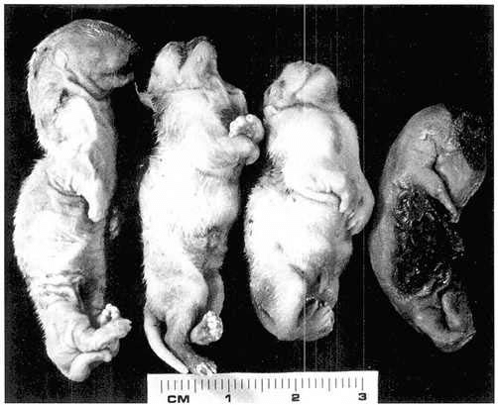

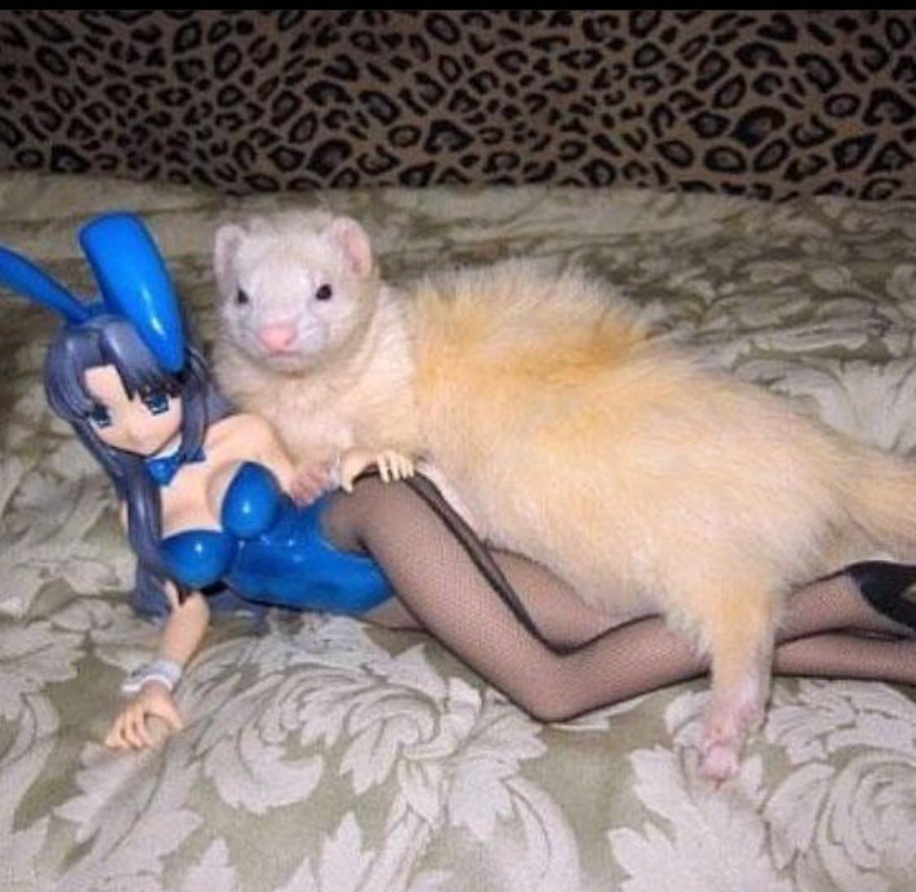
’’What are you doing step Hob!?’’

